Travel itinerary:

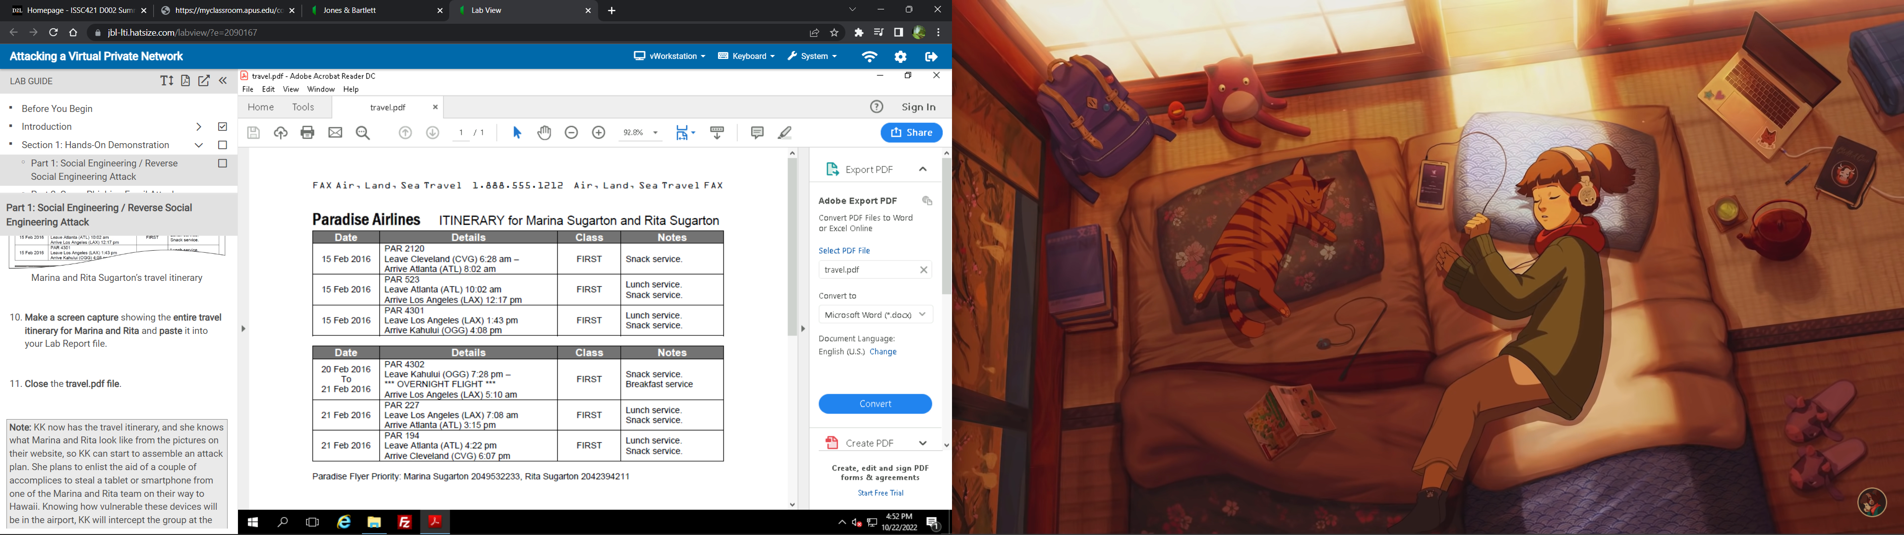

Email:

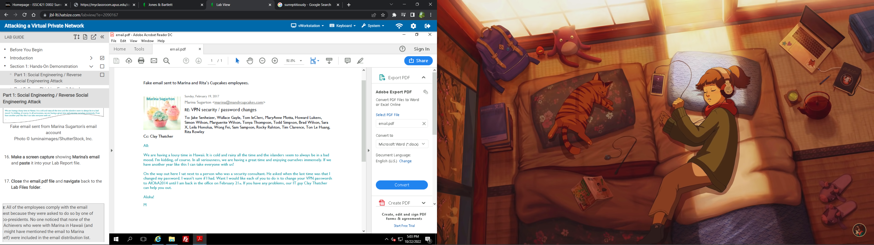

I picked this one because it is the most likely to work:

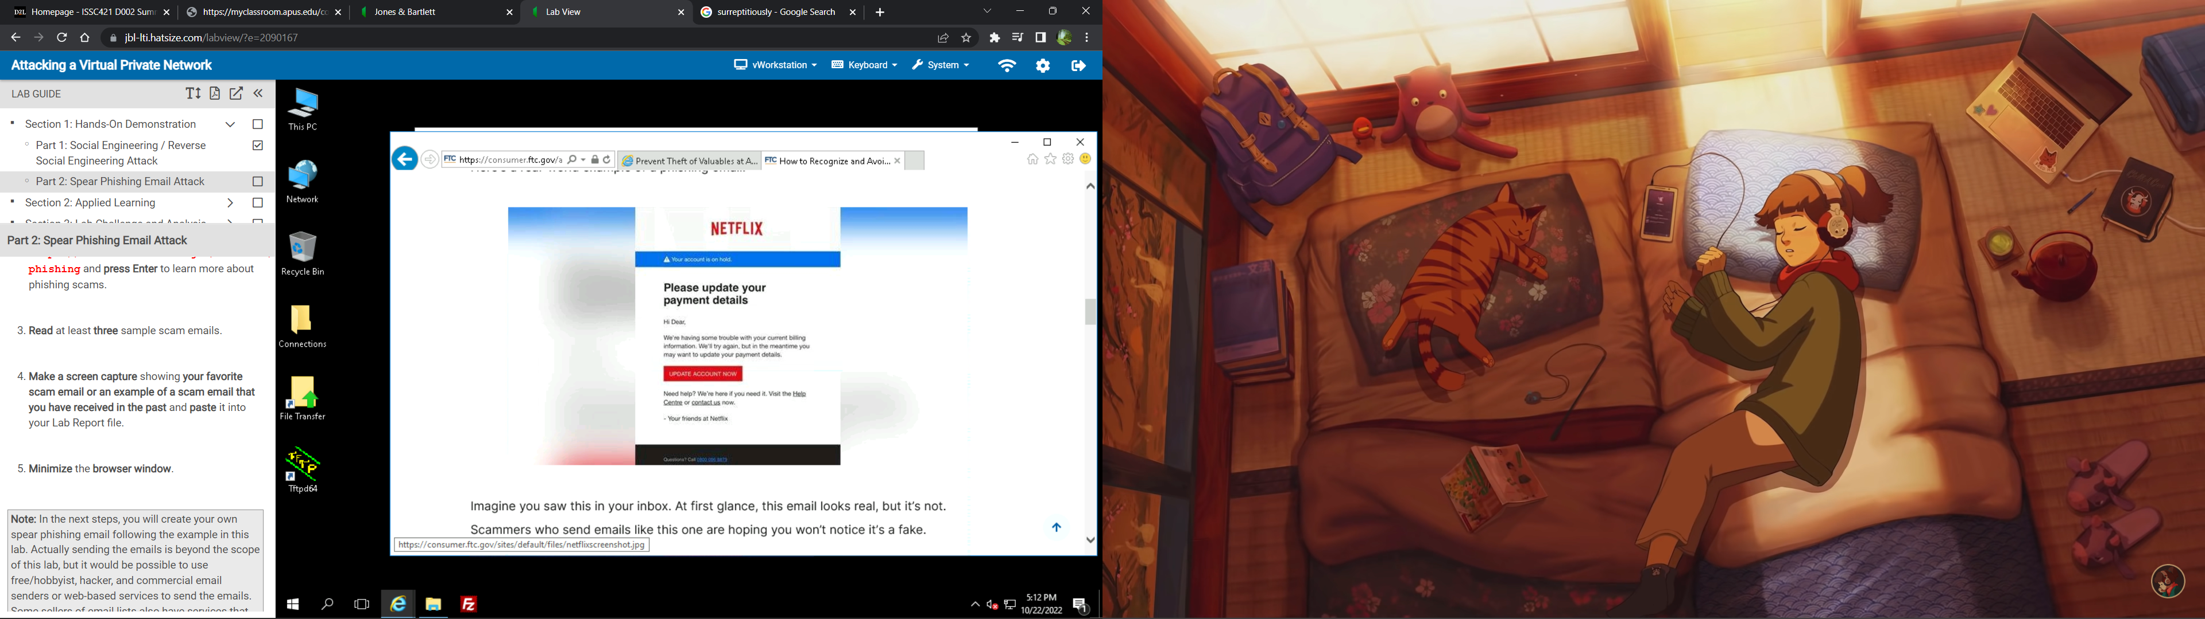

|  |  |
| --- | --- |
| To: | Charlie Roberts <croberts@beingattacked.com> |
| From: | Susan Daugherty<susan@innocentbystander.com> |
| Date: | 22 Oct 22 |
| Subject: | A favor? |

Hello Charlie,

If you or someone you know would be willing to spare some money for the families in this program that would be a huge help. I have a niece that is actually in this society and it’s taking all of my sisters’ efforts to stay afloat. [*Click here*](https://..172.30.0.99)to give not only her family but many others a little bit more time with their loved ones. No donation is too small.

Sincerely,

Susan